[](#https://www.elbsegelei.com/b2b-corporate-customers/)

with

**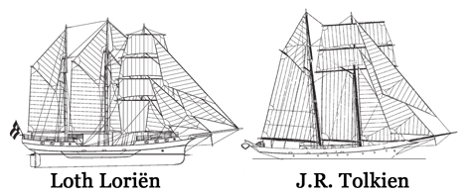**

powered by [Macintosh HD:Users:Holger:Desktop:Elbsegelei Desktop:Elbsegelei Logo:Elbsegelei_Logo_Wortmarke.eps](#www.elbsegelei.de)

**Fact-Sheet**

**ANNO 1907 - TRADITIONAL TALL SHIP – Hamburg/Elbe**

**Sailing-Teamevents and Incentives on a Three-Mast-Barkentines up to 90 people. On the Elbe between Hamburg and Glückstadt.**

* 2-6 hour event
* PAX up to 90 people
* professional crew, trademark: personable, hanseatic, authentic
* instruction of the participants in boat, maneuvers and seamanship
* the tall ship can be controlled by yourself
* motor escort boat to e.g. Taking photos of the event on request
* ship safety certificate, full insurance cover
* WiFi, smart TV
* pantry, salon, bar, toilet
* no additional costs
* various beverage packages on request
* catering and buffets on board on request
* overnight stays on board up to approx. 36 people on request
* this event can also be held on the entire Baltic Sea

Spend a day with your customers on board a venerable traditional sailing ship, a fully restored Three-Mast-Barkentine, 48 meters long.

Here you can discuss the next business steps in a relaxed atmosphere, relax together on the sundecks and experience and enjoy the Elbe between the port of Hamburg and Glückstadt.

Up to 90 passengers can sail towards an unforgettable day on board. You decide whether you want to actively help with the maneuvers, or whether the on-board crew does it for you and your team.

For weekends and longer sailing trips, the ship offers space for 36 passengers in comfortable cabins: These are the best prospects for an eventful and relaxing sailing trip.

Great menus can be conjured up in the fully equipped galley while you chat over an aperitif at the bar. The salon seats 40 guests.

The tall ship offered here looks back on an eventful history. Built in 1907 in Bergen, Norway, it was originally used as a Herring-Logger. In 1992 the ship was converted into a Two-Mast-Logger with modern rigging and a comfortable interior. In the winter of 2001/2002, the 3-Mast-Gaff-Schooner was converted again.

**Basic Prices incl .VAT**

up to 30 people PAX: 6.545 €

up to 90 people PAX: 8.945 €

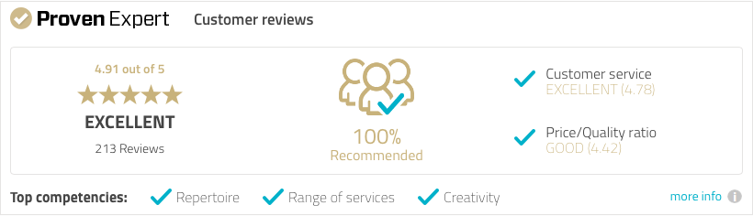

[**ELBSEGELEI.com**](#https://www.elbsegelei.com/b2b-corporate-customers/)

Am Kaiserkai 69

20457 Hamburg, Germany.

Umsatzsteuer-ID: DE 201969549

**mobil: +49 (0) 179 1124599**

**mail: holger@elbsegelei.de**

