[](#https://www.elbsegelei.com/b2b-corporate-customers/)

**and**



powered by [Macintosh HD:Users:Holger:Desktop:Elbsegelei Desktop:Elbsegelei Logo:Elbsegelei_Logo_Wortmarke.eps](#www.elbsegelei.de)

**Fact-Sheet**

**REGATTA SAILING / MATCH RACE – Hamburg/Alster**

**Sporty regatta sailing in Hamburg. With 2 - 6 sailing boats of the german sailing league. Area: Alster. Sports sailing boats teamevent "J 70" of the federal sailing league for up to 50 people.**

* 6 hour event
* PAX up to 50 people
* absolut emission free!
* up to 6 sailing boats including skipper and top location on the Alster
* active regatta sailing on high-end sports boats
* professional skipper per boat, trademark: personable, Hanseatic, authentic
* instruction of the crew in boat, maneuvers and tactics
* the sports boat can be steered yourself
* award ceremony with awards for all teams
* life jacket p.p. loan
* professional clothing (jacket and pants) on request
* motor escort boat to e.g. Taking photos of the event on request
* various beverage packages on request
* catering on request, e.g. Barbecue on the jetty

Up to six sports sailing boats sail with a skipper and 2 - 4 people per boat in a regatta or in match race mode - with and against each other. After a brief introduction by the professional skippers (all regatta sailors), the participants will be distributed to the identical boats. After a phase of sailing, including small maneuvering training, the start of the race takes place.

Now the tonnes laid out by the race management are sailed around several times in a so-called "run". As in a real regatta, there are several runs. The match race takes place in close proximity to the event area and is moderated by the race director.

This sailing event with heats, semi-finals and final races is highly recommended for beginners and inexperienced people despite its high dynamics on the water and on land. In the match race mode there are always "flying" changes of the fixed crews drawn at the beginning of the event. The boats are always re-assigned, so that not all participants have to be in action at the same time.

The "relaxation breaks" on the jetty of the sailing club can be used excellently for a drink and watching the regatta event. The learning curve is steep and the knowledge gained on land can be used excellently for the next race.

A final barbecue (on request) in the immediate vicinity of the jetty crowns the team event. The award ceremony with awards in several categories rounds off this event (on request).

Attention: Again we are here on one of the most beautiful city sailing areas in Germany against a unique backdrop in the middle of Hamburg. Our regatta event is usually held on the Alster between the 5 to 6 star hotels "Atlantic" and the "Fontenay". Due to the size of the area and the limited access to water via sailing clubs to the Alster, the organizational and time lead for this event is relatively large. Early registration is therefore essential.

**Basic Prices incl .VAT**

2 Boats, up to 12 people PAX: 3.700 €

3 Boats, up to 18 people PAX: 5.100 €

4 Boats, up to 24 people PAX: 6.900 €

5 Boats, up to 30 people PAX: 8.200 €

6 Boats, up to 38 people PAX: 9.400 €

6 Boats, up to 50 people PAX: 11.200 €

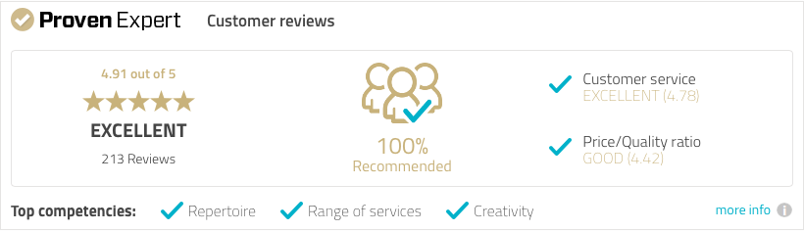

[**ELBSEGELEI.com**](#https://www.elbsegelei.com/b2b-corporate-customers/)

Am Kaiserkai 69

20457 Hamburg, Germany.

Umsatzsteuer-ID: DE 201969549

**mobil: +49 (0) 179 1124599**

**mail: holger@elbsegelei.de**

