[](#https://www.elbsegelei.com/b2b-corporate-customers/)

**and**



powered by [Macintosh HD:Users:Holger:Desktop:Elbsegelei Desktop:Elbsegelei Logo:Elbsegelei_Logo_Wortmarke.eps](#www.elbsegelei.de)

**Fact Sheet**

**CITY-COUNTRY-RIVER / TEAMEVENT - Hamburg/Elbe:**

**City-Country-River-Teamevent in Hamburg. Sailing and iconic VW Bullis. Cruising along the Hamburg backdrop. Urban, maritime team event for up to 22 people.**

* 6 hour event
* also available as a small tour (Quick & Dirty)
* PAX up to 22 people
* 3 hour discovery tour in iconic VW Bullis
* 3 hours sailing trip on an elegant and modern sailing yacht
* 2 individual and authentic experiences become a great adventure
* renewal of the group by lottery
* professional guides and skippers, trademark: friendly hanseatic
* small exploratory walks with new perspectives on the Hanseatic city
* instruction of the crew in boat, maneuvers and seamanship
* the yacht can be controlled by yourself
* full insurance coverage
* optional: various beverage packages
* optional: fish sandwiches and tubers of beer when exchanging vehicles or BBQ on the Elbe beach
* start Hafencity - Wedel - end Hafencity
* start Wedel - Hafencity - end Wedel
* no additional costs
* catering on request

An individual sailing trip with the "Elbsegelei" on a modern and elegant sailing yacht (river) and an individual city tour with "Waterkant tours" in iconic VW-Bullis (country). Both in the middle of Hamburg, the most beautiful city in the world. At the apex of the respective tours all participants meet for a fish sandwich and the vehicles are exchanged.

On this city-country-river tour, two authentic and genuine Hanseatic experiences merge into a very special adventure along the Hamburg backdrop, away from the usual routes. Waterkant tours and the ELBSEGELEI combine an individually guided sailing trip with a professional skipper, with a unique city tour in well-maintained VW Bullis with patina. Guides included, of course. You dive into the microcosm of the Elbe metropolis and get to know and love our

hometown from an unusual perspective. On the water, on land and through the city.

One part of the team sails with the Elbsegelei-Yacht from Hamburg over the Elbe to Wedel (approx. 25 km) and experiences one of the most extraordinary rivers in Europe, which was previously reserved only for yacht owners on the Elbe. In Wedel, after a fish roll and a tuber of beer, the "vehicles" are exchanged. You are now switching to the feel-good carriages of Waterkant tours with an individual character and your own trunk bar. You will be shown selected spots along the route by real Hamburg boys or girls and get to know Hamburg from new perspectives!

Deceleration and a feel-good atmosphere are very important on every tour. No previous knowledge is required for the sailing trip and you can freely choose the level of activity on the sailing yacht. No age restrictions.

**Basic Prices incl .VAT**

Up to 16 people PAX: 2.500 €

17 – 22 people PAX: 3.500 €

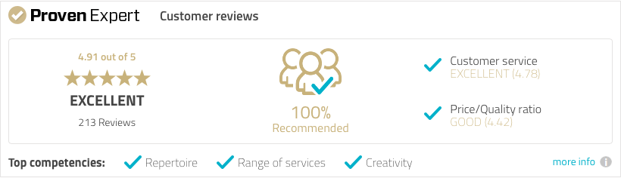

[**ELBSEGELEI.com**](#https://www.elbsegelei.com/b2b-corporate-customers/)

Am Kaiserkai 69

20457 Hamburg, Germany.

Umsatzsteuer-ID: DE 201969549

**mobil: +49 (0) 179 1124599**

**mail: holger@elbsegelei.de**

